
Session 2 Supporting Material
UI and UX Design, Wireframes and Prototypes. Reference for Activities 1 to 3: read the section an activity names.
Fictional organisation and synthetic data: the organisation, its people and its figures are invented for teaching.
Each section supports one activity. The worked examples use a different journey from the activities: a tenant changing how Kestrel Moor Homes contacts them (by text, email or letter). Borrow the method, not the screens.

Section 1. Finding user needs in evidence (Activity 1)

What counts as evidence
• A line from a persona in Case Brief Part 3: name the persona and quote the line.
• A line from a stakeholder interview in Case Brief Part 2: name the speaker.
• Rows in the Repair Requests data: give the request_id, or the filter you used and the count.
The personas describe two tenants. The data describes 150 requests, so it can show needs the personas do not.

Filtering the data
In Excel, click any cell in the table, choose Data, then Filter, and use the arrow on a column heading to pick the values you want. Clear one filter before you set the next. The CSV opens in any spreadsheet tool (LibreOffice Calc, Google Sheets or Numbers); if you have none, work from your partner's shared screen.
Column | What it tells you
vulnerability_flag | Y if the household has a recorded vulnerability that affects how the repair is handled.
vulnerability_note | The vulnerability in a few words. Blank when the flag is N.
channel | How the report arrived: Phone, Web form, Email or Housing officer.
category | The repair category chosen when the request was logged.
priority_assigned | Emergency, Urgent or Routine, given at triage (Case Brief Part 4).
repeat_report | Y if the tenant had already contacted Kestrel Moor about the same problem.

Writing a need
A need says what the user must be able to do. A design rule says what the screens must do so that they can. Keep features (a dropdown, an app, a button) out of the need; they belong in the design. Accessibility needs are wider than sight: hearing, movement and dexterity, memory and attention, reading and language all count.

Worked row (contact preferences, not repairs)
User need | Evidence | What the design must do
Hear about my repair in a way I can use, including by letter | Maureen Hughes (Case Brief Part 2): "some won't use an app, full stop"; Phase 1 scope: updates by text, email or letter | Offer text, email and letter as equal choices, with none pre-selected

In Activity 1 you write the need and its evidence. The third part, what the design must do, comes in Activity 2: each annotation on your screens cites a need from your table.

Section 2. Wireframing the repair journey (Activity 2)

What a low-fidelity wireframe contains
• Real words: the actual question, labels, button text and messages. The words are most of the design.
• Boxes for fields and buttons, in one column, in the order the tenant meets them.
• Every path you are asked for: the normal path, the error state and the emergency stop.
• Annotations: a decision and its reason, citing a need from your Activity 1 table, a point of the standard or Case Brief Part 4.
• No colours, logos, photos or exact spacing. The visual design comes later.

Phone screen checklist
• A heading that asks one question in plain words.
• A visible label above every box; any hint goes under the label, never only inside the box.
• Choices as radio buttons or large tappable options, with none pre-selected.
• One main button, full width, that says what it does (Continue, Send report).
• Limits stated before people hit them, such as how many files can be added and how large they can be.
• Tap targets at least 24 by 24 CSS pixels, the WCAG 2.2 AA minimum (2.5.8). Aim for about 44 by 44 for main buttons (2.5.5, a AAA criterion), with space between targets.
• Box borders and button edges at 3:1 contrast or more against the background (WCAG 2.2, 1.4.11 Non-text Contrast), so people can see where to type and tap.

Worked example: an error state (contact preferences)
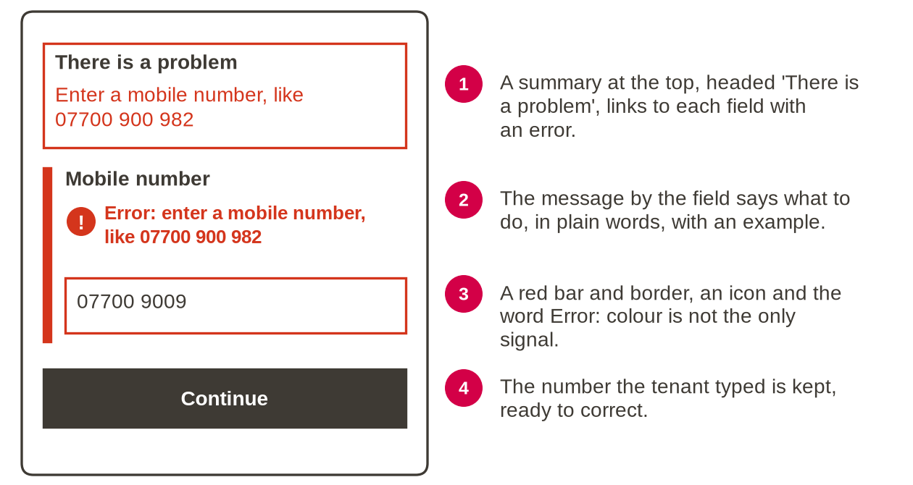
A tenant chose text messages and typed a mobile number that is too short. The pattern follows the GOV.UK Design System error summary and error message components (checked October 2026). The example number comes from a range kept for drama and fiction.

The emergency interrupt pattern (shown on a GP surgery's form)
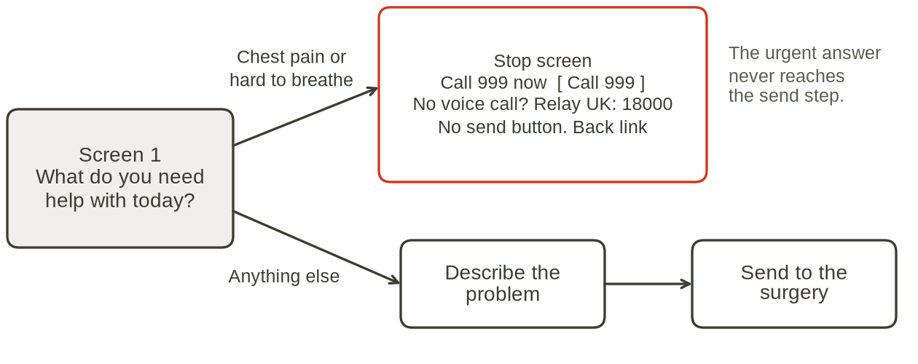
When an answer means the user must act now, the question that finds it comes first, before any sign-in, and the flow stops at the very next screen. The stop screen says plainly what to do now; gives the number and a large button that starts the call; gives a route for people who cannot make a voice call (on this GP form, Relay UK's 18000 for 999); has no send or submit button, so nothing waits in a queue; and has a way back for anyone who chose it by mistake. For Kestrel Moor, the emergencies that trigger the stop and who the tenant must call are in Case Brief Part 4, printed in the Activities document.

Building it in draw.io
1 Go to app.diagrams.net and choose Device when asked where to save. Then choose File, Open from, Device, and pick Session 2 - Wireframes (starter).drawio from the Starter Files zip.
2 Each page tab at the bottom is one screen. Copy shapes from the Components page (select, Ctrl+C, then Ctrl+V on your screen) and draw inside the phone frame: boxes and words only.
3 To start a screen from an earlier one, right-click its page tab and choose Duplicate.
4 Add an annotation with a Note shape (type note in the shape search box) beside the frame.
5 To link: right-click a shape, choose Edit Link, select the second option, pick the page and click OK.
6 To test: hover over the linked shape and click the link that appears. You should land on the page you chose.
7 To save: File, Save as, Device. Then post the .drawio in your breakout room chat so your partner can open it.
No draw.io? Use PowerPoint: one slide per screen; select a shape, then Insert, Link, Place in This Document (This Document on a Mac), and choose the slide; test it in Slide Show. Or use paper: one sheet per screen, arrows for the links, and a photograph of each sheet.

Section 3. Reviewing and explaining a design (Activity 3)
The five-point check for Activity 3 is printed in the Activities document. Points 4 (contrast) and 5 (tap targets) need colours and sizes, so on a low-fidelity wireframe you can only check what the annotations ask for.

Worked review comment (contact preferences, not repairs)
Not actionable: "The contact page isn't very accessible."
Actionable: "Contact preferences, screen 1: the mobile number box has only grey hint text inside it, which disappears when you type (point 1, visible labels). Add the label Mobile number above the box and move the example under the label."
The second comment names the screen, what fails as the reviewer saw it, the point of the standard and a fix the designer can make straight away.

Giving and taking review comments
• Comment on the design, not the designer: "this screen", not "you".
• One problem per comment, the most serious first.
• Suggest a fix; the designer decides.
• When you receive a comment, change something or say why not.

Explaining a design to two audiences (contact preferences)
Audience | Two sentences
A tenant | You choose how we contact you about repairs: text, email or letter. If you choose text, we ask for your mobile number on the same screen, and you can change it at any time.
A developer | Contact preference is a required single-choice radio group with no default; choosing Text reveals a required mobile number field, validated on Save. Errors render a summary linked to the field plus an inline message, and the entered value is preserved.

For a tenant: what they can do and what happens next, in everyday words. For a developer: states, rules and behaviour, not colours.

